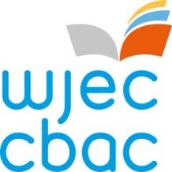 | 

PARTIAL CONSORTIUM ARRANGEMENTS FORM

Summer 20__

Please read the following guidance to establish if you have a partial or full consortia arrangement before completing the form.
This form should be completed:
- If your centre is teaching a WJEC/Eduqas specification at your centre but sends some (i.e. one or more but not all) candidates to other centres to be taught the specification or component/unit and have their work marked there by a teacher at that centre
- For your own centre’s candidates, i.e. only those on your roll
- Do not complete this form if all of your candidates for a specification or component/unit are taught at another centre. In this scenario the teaching centre will need to complete the JCQ Centre Consortium Arrangements Form on the CAP (accessible via the WJEC Secure website)
- By 31st January for the summer series

Centre Name: | Centre Number:
Exam Officer name: | Exam Officer Email:

Specification  Title | Subject /  Unit Code | Candidates taught and marked elsewhere |  | Name of  Teaching Centre /Centre Number | Total number of entries for entering centre
Specification  Title | Subject /  Unit Code | Number | Name | Name of  Teaching Centre /Centre Number | Total number of entries for entering centre

Completed forms should be emailed to consortia@wjec.co.uk

